**Time**

Stasis and Activity

Dance 1

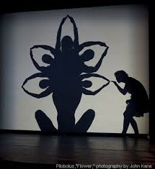

**Choreographic tools**

Cannon (overlapping)

Echo(non-overlapping)

**Meter**

Note Values

(whole, ½, ¼, 1/8)

4/4 meter

Accent

**Acceleration**-gradually getting faster

&

**Deceleration-**gradually getting slower

**Pulse**-steady beat

**Tempo**-how fast or slow you move

**Rhythm**-repetitive pattern of movement